From Australia to Zimbabwe, the Number of Women Pastors Rises
Nerida Taylor Bates | Spectrum August 29, 2025
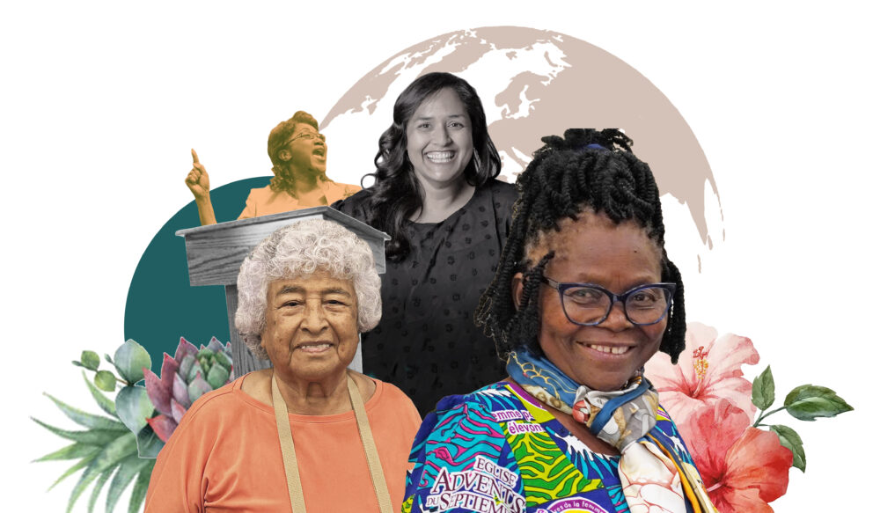Based on the Association of Adventist Women’s (AAW) most recent 2019 global base count and additional surveys and interviews, we estimate that the number of women ministers in the Adventist Church is at least 1,075. This is an 18 percent increase in three years, representing both a spike in women pastors as well as improved data gathering methods—which sometimes has had to rely on off-the-record sources. Previously, uncounted women included ministers in Japan and Russia who have been quietly leading churches for 20 years.
This number does not include the several thousand Adventist women pastors in China. This is due to the region’s denominational leaders’ request not to be included due to political sensitivities.
The growing acceptance of Adventist women as ministers is not limited to countries where they were already common; their increasing presence in smaller communities worldwide reflects that cultural shifts are widespread. No longer can any division claim its culture forbids women from holding spiritual leadership in the church. The often proposed idea of allowing the Chinese, North American, and European divisions to ordain women—but not other divisions—ignores hundreds of women thriving in church leadership outside these places. And this reality appears to have played a role in the selection of church leaders at the 2025 General Conference Session (GC).
Examples of steady growth in the number of women pastors can be found across the globe, as they account for at least half of the growth since the 2022 GC Session. Three women lead churches in the 10/40 window, an area with religio-political restrictions that make naming them dangerous.
Additionally, two women have been hired as pastors in India, and Mongolia now has eight.
A deep dive into numbers
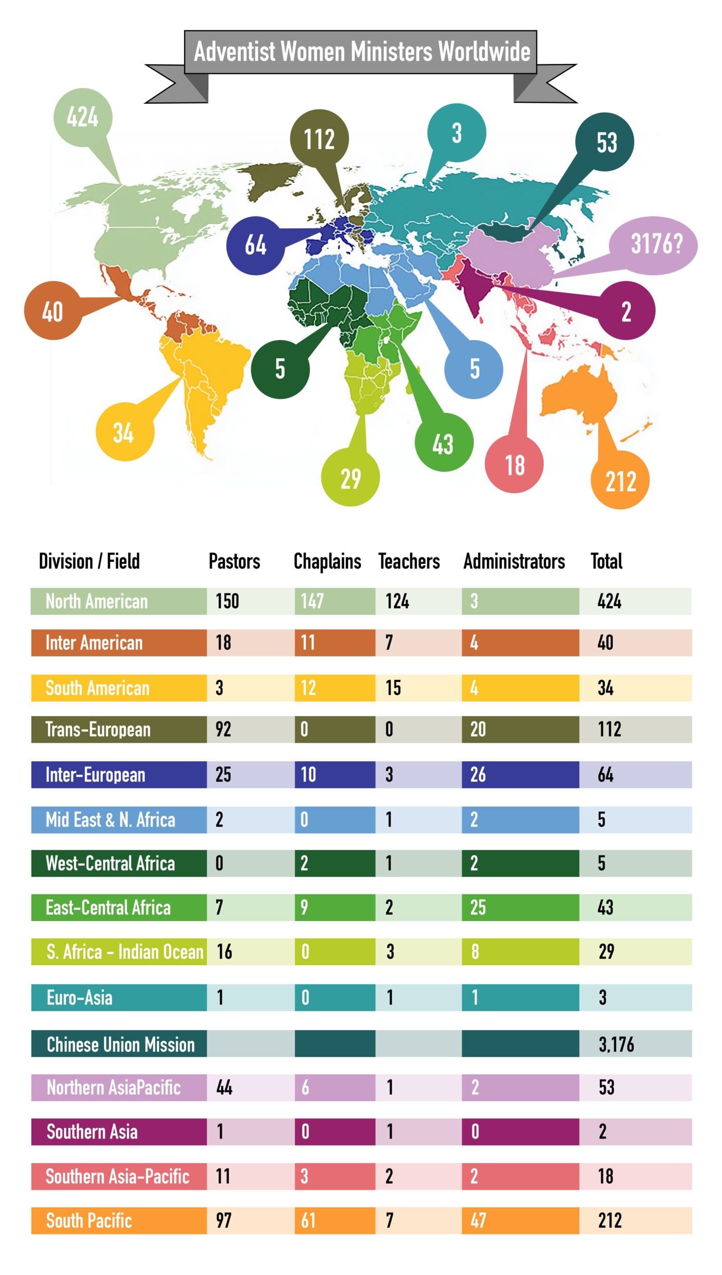
Pastors of this count are defined as women, with or without pay, who fill the primary or associate pastoral role in a recognized Adventist company or church. The terms “minister” and “pastor” are used interchangeably; neither implies ordination. Chaplains include women who are certified or educated as ministers and locally hired as chaplains. Certification usually requires ordination. The GC certifies chaplains who hold a ministerial license, and in some cases, they will personally issue the license. However, the GC does not license qualified chaplains employed in a division that refuses to issue ministerial licenses to women.
Religion teachers were also counted if they taught religion or theology at least part-time at the secondary or tertiary level. And women administrators, including those in Women’s or Children’s Ministries, are only counted if they have a degree in ministry or theology.
The percentages of the count are estimates based on the division pastoral counts and are organized into a fraction. Female religion teachers and chaplains are the numerator, and pastors—including ordained chaplains, teachers, and administrators—are the denominator.
For the last 40 years, the AAW has periodically counted the number of women pastors, during which requests for information are sent to the ministerial association of every division along with some unions. The education departments from the Ukraine Union, two Indian Unions, and the North American Division (NAD) replied directly. While in two other divisions, the requests were referred to the women’s ministry directors, leading to fruitful conversations. However, only the NAD provided full counts of the women ministers and chaplains under its reach. The two largest European divisions’ counts were based on the number of invitations sent for their ministers’ retreat for women. And the South Pacific Division gave a partial count, omitting religion teachers and the Papua New Guinea Union.
The rest of the counts were obtained through a myriad of contacts, such as theologians and journalists, as well as searches of conference directories. If not verified on an official Adventist Church website, two sources were sought to document each pastor.
To compile an accurate count, AAW also worked with Time for Equality in Adventist Ministry (TEAM) to contact many scholarship recipients. TEAM offers these scholarships to women interested in studying religion at Adventist institutions worldwide—provided that a local church indicates that it will hire them upon graduation. Because the schools need the tuition money, the pressure falls on the conferences and unions to ensure that these women are able to find employment in their prospective fields of study. This has been a driving force behind the increase of women pastors. However, concerns have arisen that some of these accepting communities have reached their capacity for supporting these women. Either the number of students must decrease, or a concerted effort must be made to educate non-accepting communities in welcoming women in these roles.
The majority of women pastors and chaplains of this count received four years of pastoral training. In the countries of Trinidad, Papua New Guinea, and Thailand, only Bible workers or certificate pastors were counted; as well as lay pastors throughout Chile, Brazil, and Kenya, respectively, who led church companies. Though 200 women holding pastoral certificates were reported in Papua New Guinea, the number could not be verified. At the 2025 GC Session, women’s ministry directors from the Solomon Islands proudly provided AAW their lay pastors’ certificates. However, these are also not included in the count.
The positives
In pockets around the globe, there is growing acceptance for women ministers. A woman leads a church in every division, with the exception of the West Central Africa Division. However, they do have women chaplains, a theologian, and a historian of early Christianity. Furthermore, In Liberia, Glory Baysah, former vice president of Academics at the Adventist University of West Africa, has just been appointed the institution’s new president. AAW’s recent Woman of the Year award recipient, Anathasie Nda, pastored in Cameroon for 30 years and is believed to be the first Adventist woman to baptize on the African continent. Additionally, in the 80s, several women led churches in Mauritius and Madagascar.
The Junia Award, which the AAW now awards by division annually to women pioneering in church leadership, has shed light on the fact that women ministers exist in every division. Though there was concern that these women in ministry might receive retribution, they feel they are safer when the world church knows they exist. They also expressed satisfaction that their calling is being seen and serving as an example for other women pastors.
Joining long-time pastors Maria Silvia Neri Castrejon of Mexico, Anathasie Nda of Cameroon, and Juana Dina Salas Montoya of Peru in retirement since the 2025 GC Session are Halyna Moskalenko of Ukraine, Ernestine Rabesalama of Madagascar, Margaret Ramsarran of Guyana, Delia Bella Machore Pinnock of Nicaragua, Mara Núbia Sales of Brazil, and the theologians Petronella Karpati of Hungary and Silvia Scholtus of Argentina. The work of these women highlights why limiting acceptance of women ministers to only certain divisions does a disservice to the greater Adventist community.
In Africa, South America, and much of Asia, 70 percent of churches have a woman—usually a lay woman—preaching five to seven times a year, which is more than most NAD churches. This bodes well for the increasing acceptance of women pastors. Once one hears a good sermon by a woman, prejudices against women in ministry can more easily be shed.
The negatives
Still, losses do exist. The Philippines had a long tradition of women Bible workers and ministers. In his July 2013 contribution to the Theology of Ordination Study Committee’s work, “The Ordination of Women in Seventh-day Adventist Policy and Practice, Up to 1972,” David Trim notes that this tradition dates back at least to the 50s, and was part of why the Far Eastern Division originally asked about ordaining women in 1972.
From 1975 to 1989, the Philippines had the most women licensed as ministers of any division, according to research I have publicly presented titled “A Worldwide Phenomenon: The Seventy Women Licensed as Ministers in the Seventh-day Adventist Church 1975-1989.”
By the 90s, there were dozens of women ministers in the Philippines, but the trend appears to have tapered off. Since Director of Adventist Health Ministries Jadaza Hintay moved into the Northern Luzon Philippine Union Mission’s administration, there might only be one woman left working as a pastor there.
Similarly, Zimbabwe had three women pastors in the 90s, but is now struggling to maintain one, whose photo and first name were removed from the church website due to negative publicity.
In central Africa, there is a growing segregation practice of placing ministerially trained women into Women’s Ministry leadership and few other positions. This creates a sense that theologically trained women can only work for women. While this is a drawback, the area has the most educated Women’s Ministry departments in the world. It has become a safe place for trained women ministers.
Furthermore, an increasing number of women are studying theology. At Avondale University in Australia 28 percent of ministerial students are women.
The current mood of women pastors
For too long, the church administration has encouraged unordained women ministers in some communities but remained silent about not allowing women to be elders and deaconesses—let alone ministers. Some locations still struggle to allow women on the podium.
In 2024, the Adventist Review published an article requested by AAW in which Bible scholar Roy Gane undermined attempts to exclude menstruating women from church participation.
Women ministers around the world who are working in non-accepting communities are crying out for church validation. One commissioned woman pastor had her own church refuse to ordain a woman to be an elder. Women pastors have been shunned by peers and administrators, excluded from pastoral retreats, and more. One was even fired because “she worked too hard,” which was allegedly preventing her from “getting married.”
Until fellow male pastors and administrators are held accountable for prejudicial treatment of their women peers, there will continue to be significant stress placed on women in ministry. To help alleviate this strain, AAW has started an online monthly meeting to support Spanish-speaking ministers worldwide.
Lessons from the GC Session
In a far corner booth of the exhibit hall during the 2025 GC Session, I presented a global chart of this pastoral data. My pitch, after explaining the count, was simply to say these women, waving my hand over the globe outside of America and Europe, want to be seen. I actively targeted delegates from outside NAD and found a near-universal interest in the number of women pastors. About a quarter of delegates even took a photo of the chart to share it with others.
Additionally, when discussing women pastoring churches without pay, almost all of these men strongly disagreed with the practice. To my surprise, 70 percent of the delegates were very positive in support of women ministers. And 25 percent were very surprised at the data, though they did not publicly engage. The remaining five percent sought to challenge what I had presented. When faced with these unconvinced delegates, I made every effort to disengage, stating that while AAW strongly supports women’s ordination, the core purpose of our booth was to make sure all women ministers are seen. If debate persisted, I said, “We will not agree, but these women exist and we are bringing them to your attention.”
Often, other delegates, their wives, and in one instance, one of their 10-year-old daughters, excitedly began telling opposing delegates about a particular woman in question. One delegate insisted that the woman was a pastor at a “house of prayer,” not a “church”—a nuance that is lost on me. Another did not consider the associate pastor for families and children a “real pastor.”
In another instance, one delegate repeatedly shouted, “No, no,” pointing to the numbers in the Inter-American Division. With translation, I was able to determine that he took exception to my listing only seven women religion teachers. “I know 7 in my area of Mexico alone. There are many, many more,” he said. He was undoubtedly correct.
Two treasurers raised the strongest disagreement over the employment of local women pastors. The women in question were a chaplain at a university who was also given the formal title of associate pastor of the church, and a language school head who was voted by her local church—with conference approval—as pastor. While I counted these women in the pastor category, their primary employment remains listed as their initial function, and hence, the treasurers were not aware.
Delegates informed me of 15 more women ministers who have been added to the list, and about five argued that there were no women pastors in their country.
Furthermore, the number of women pastors was a topic of conversation during leadership-selection deliberations. I was informed by two persons present that when the nominating committee was asked to give alternative nominees for the GC Associate Ministerial Director position, it was stated that “if there are four to six thousand women pastors,” perhaps it is time to have a woman nominee. Subsequently, Crystal E. Ward was nominated and voted in.
On a more visceral level, AAW had a photo mosaic of women pastors from around the world baptizing, leading communion, and officiating weddings that together made an inviting image of Jesus reaching out for a hug. Though it was a popular point of attention, the mood shifted when viewers realized what the small photos represented. In the mosaic, people found their home pastor’s picture, and some even found their own photo. One pastor sent her teenage son to scour through all the photos to find hers. This piece of art incited shock and, even more so, joy, sometimes expressed through happy tears. It was a reminder that women pastors reflect the approachable and loving nature of Jesus. And these brave women continue to serve as his hands and feet throughout the world.
Special thanks to Ruth Peeters, AAW board member, who researched the Spanish and Portuguese-speaking women church leaders.
Graphics by Jared Wright for Spectrum.

About the author
Nerida Taylor Bates, MD, PhD, is president of the Association of Adventist Women (AAW), Loma Linda, California. She was born in Sydney, Australia, and has spent much of her educational and professional career at Loma Linda University. More from Nerida Taylor Bates.

